## ****Name : ntwari patrick****

**Id : 29089**

**Course : PL/SQL**

## ****Step 1: Problem Definition (2 pts)****

**Business Context:**  
A small-to-medium fruit distribution company supplies fresh fruits (bananas, mangoes, oranges, pineapples, etc.) to households and local shops across different regions in the society.

**Data Challenge (2–3 sentences):**  
The company struggles to identify which fruits generate the highest revenue in each region and season. They also want to understand customer purchasing trends, growth patterns, and segment customers into spending groups to guide marketing campaigns.

**Expected Outcome:**  
Insights into the top 5 fruits by revenue per region/quarter, customer purchase quartiles, and sales trends (running totals, growth rates, and moving averages) to support targeted promotions and better inventory management.

## ****Step 2: Success Criteria (5 measurable goals)****

**Top 5 fruits per region/quarter** → RANK()

**Running monthly sales totals** → SUM() OVER()

**Month-over-month growth** → LAG() / LEAD()

**Customer quartiles by total fruit purchases** → NTILE(4)

**3-month moving average of fruit sales** → AVG() OVER()

## ****Step 3: Database Schema (ERD + Tables)****

### Tables

**customers** → customer info (buyers of fruits)

**fruits** → product catalog (different fruits and categories)

**transactions** → sales (records of each fruit sale)

### Example rows

**customers**: (1001, "Alice", "Kigali")  
**fruits**: (2001, "Banana", "Tropical")  
**transactions**: (3001, 1001, 2001, 2025-01-15, 500)

CREATE TABLE transactions (

transaction_id NUMBER PRIMARY KEY,

customer_id NUMBER NOT NULL,

fruit_id NUMBER NOT NULL,

sale_date DATE NOT NULL,

quantity NUMBER NOT NULL,

amount NUMBER(12,2),

CONSTRAINT fk_customer FOREIGN KEY (customer_id)

REFERENCES customers(customer_id),

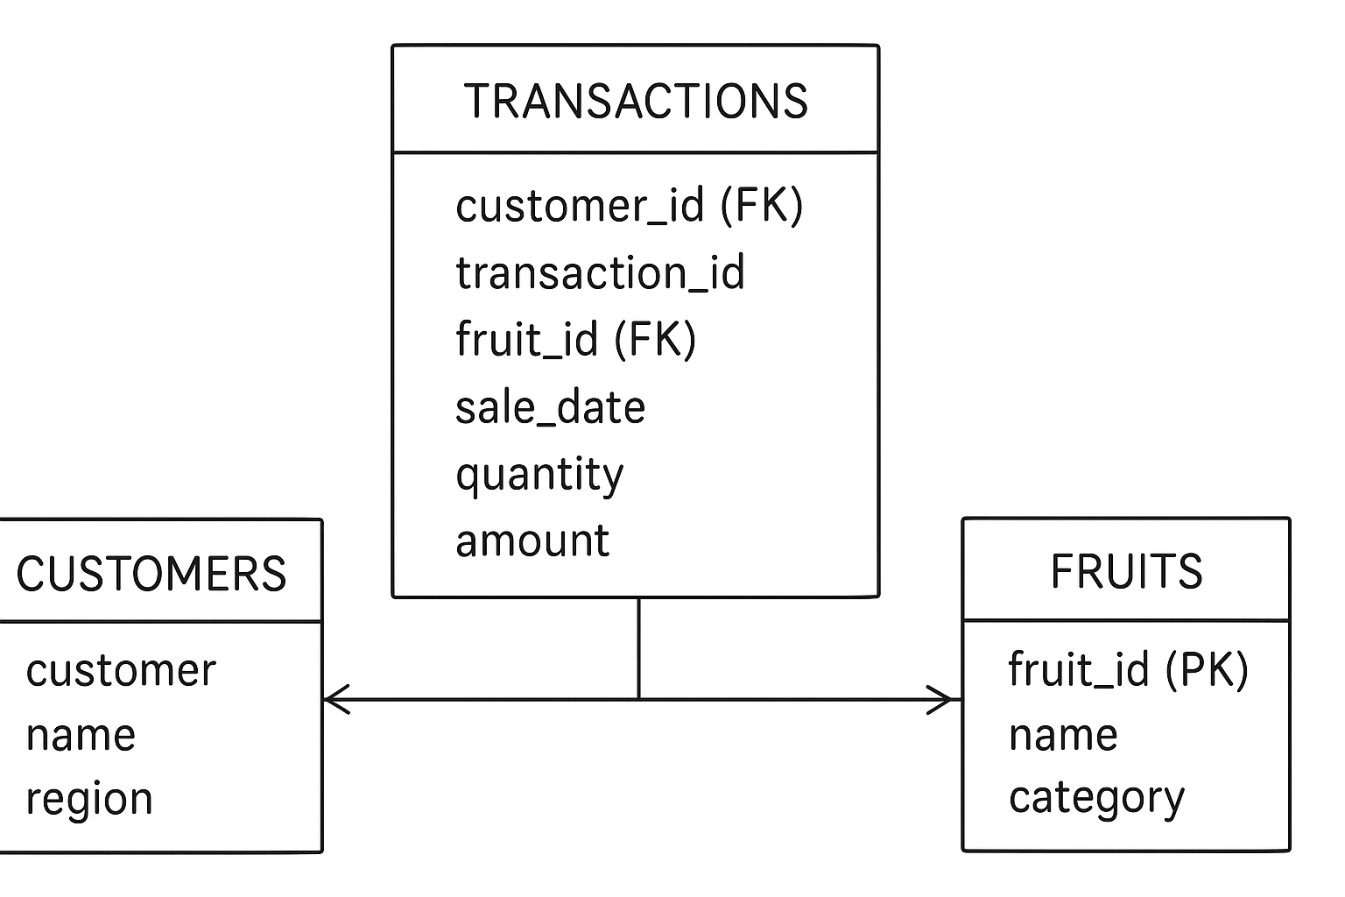

CONSTRAINT fk_fruit FOREIGN KEY (fruit_id)

REFERENCES fruits(fruit_id)

## ****Step 4: Window Function Examples (adapted to fruits)****

### A. Ranking – Top fruits per region & quarter

WITH fruit_sales AS (

SELECT

f.fruit_id,

f.name AS fruit_name,

c.region,

TRUNC(t.sale_date, 'Q') AS quarter_start,

SUM(t.amount) AS total_revenue

FROM transactions t

JOIN fruits f ON t.product_id = f.fruit_id

JOIN customers c ON t.customer_id = c.customer_id

GROUP BY f.fruit_id, f.name, c.region, TRUNC(t.sale_date, 'Q')

)SELECT

fruit_name,

region,

quarter_start,

total_revenue,

RANK() OVER (PARTITION BY region, quarter_start ORDER BY total_revenue DESC) AS fruit_rankFROM fruit_salesWHERE RANK() OVER (PARTITION BY region, quarter_start ORDER BY total_revenue DESC) <= 5;

### B. Aggregate – Running monthly totals

SELECT

TRUNC(sale_date, 'MM') AS month_start,

SUM(amount) AS month_total,

SUM(SUM(amount)) OVER (ORDER BY TRUNC(sale_date,'MM')) AS running_totalFROM transactionsGROUP BY TRUNC(sale_date, 'MM')ORDER BY month_start;

### C. Navigation – Month-over-month growth

WITH monthly_sales AS (

SELECT TRUNC(sale_date,'MM') AS month_start,

SUM(amount) AS total_sales

FROM transactions

GROUP BY TRUNC(sale_date,'MM')

)SELECT

month_start,

total_sales,

LAG(total_sales) OVER (ORDER BY month_start) AS prev_month,

ROUND(((total_sales - LAG(total_sales) OVER (ORDER BY month_start))

/ NULLIF(LAG(total_sales) OVER (ORDER BY month_start),0)) * 100, 2) AS growth_pctFROM monthly_sales;

### D. Distribution – Customer quartiles by spending

WITH customer_revenue AS (

SELECT c.customer_id, c.name,

SUM(t.amount) AS total_spent

FROM customers c

JOIN transactions t ON c.customer_id = t.customer_id

GROUP BY c.customer_id, c.name

)SELECT

customer_id, name, total_spent,

NTILE(4) OVER (ORDER BY total_spent DESC) AS spending_quartileFROM customer_revenue;